Capstone Project

Emergency Room Visit Prediction Using Medicare Inpatient Claims and Patient Demographic Data

Deepa Sharma

Abstract:
This study develops a machine learning model to predict Emergency Room (ER) visits among Medicare enrollees based on inpatient claims and patient demographic data. The analysis uses de-identified data from the Centers for Medicare & Medicaid Services (CMS), including chronic conditions grouped via the CCW 30 Chronic Conditions Algorithm. Feature engineering included ICD grouping, one-hot encoding of categorical variables (e.g., age group, sex, entitlement reason), and derivation of new features.
Three models—Logistic Regression, Random Forest, and XGBoost—were trained and evaluated. Performance was assessed using accuracy, precision, recall, F1-score, and ROC-AUC. XGBoost performed best (ROC-AUC = 0.88). Key features associated with ER visits included chronic kidney disease (CKD), ischemic heart disease (IHD), and lung cancer diagnosis. This research demonstrates the potential of administrative claims data to support proactive care coordination and reduce avoidable ER visits for healthcare cost savings as well as better patient experience.

Introduction:

The study aims to analyze and predict Emergency Room (ER) visits among Medicare beneficiaries using inpatient claims data. By examining patient demographics (age & sex), entitlement reasons, and a wide range of chronic conditions codes (ICD), the goal is to identify key predictors that influence ER utilization in Medicare enrollees.

Through Exploratory Data Analysis (EDA) and machine learning models such as Logistic Regression, XGBoost, and Random Forest, this analysis assesses the relative impact of clinical and demographic factors on the likelihood of a Medicare enrollee visiting an Emergency Room for care. Hypotheses tested includes whether chronic illnesses, older age, and entitlement reason significantly correlate to ER visits. The findings can help healthcare providers target high-risk populations and reduce unnecessary ER utilization through care coordination and preventive care.

Literature Review:
Many previous studies have aimed to predict hospital admission during emergency department (ED) triage. Some studies have developed and validated a risk-scoring model, with a particular emphasis on medication-related factors, to predict emergency department (ED) visits among patients from a specific demographic [Suh, Y., Jeong, J., et al. 2024]. Most of these models rely solely on data gathered at triage, including demographics, vital signs, chief complaints, nursing notes, and initial diagnostic tests. To date, the majority of studies aiming to predict hospital admission in ED patients focus on the general ED population [Y. Sun, B.H. Heng, et al. 2011]. This study used a series of geriatric syndromes and assessments to predict hospital admission, demonstrating that these factors are strong predictors of hospital admission in older emergency department (ED) patients[Clare Allison Parker, et al. 2018]. In recent years, machine learning has emerged as a promising tool for predicting hospital admission among older adults visiting emergency departments (EDs), a population known for its distinct medical and functional complexities.
A study by Fabrice Mowbray, et all. (2020) applied various ML algorithms to predict ED admission in older adults, utilizing data from the interRAI multinational ED study, which involved 2274 patients aged 75 and older across Canada. The researchers identified five primary features—home intravenous therapy, time of ED presentation, need for formal support services, walking independence, and presence of unstable medical conditions—that were most predictive of hospital admission. Among the five ML models tested, gradient boosted trees demonstrated the highest accuracy (AUC = 0.80) in predicting hospital admission, providing valuable insights into the clinical decision-making process[Fabrice Mowbray, et al. 2020].
Other studies have also been performed using machine learning to robustly predict hospital admission using triage information and patient history. The addition of historical information improves predictive performance significantly compared to using triage information alone, highlighting the need to incorporate these variables into prediction models (Woo Suk Hong et all, 2018) [Hong, Woo Suk, et al. 2025].
The challenge lies in the complexity of predicting ER outcomes. A variety of factors—including a patient’s clinical history, demographics (age, sex, ethnicity), socio-economic status, and presenting conditions—can influence the outcome. Modeling the relationships between these factors and ER visit changes is difficult due to the variability in both patient data and the unpredictable nature of emergency care.

Research Questions:
This study aims to explore the relationship between patient characteristics and Emergency Room (ER) utilization using claims and patient demographic data. Specifically, it investigates which chronic conditions, as defined by ICD codes—such as asthma, chronic kidney disease (CKD), and chronic obstructive pulmonary disease (COPD)—are most strongly associated with ER visits. Additionally, the research examines whether demographic factors, including age group and sex, along with insurance entitlement reason codes (such as disability or end-stage renal disease), significantly influence the likelihood of an ER visit. Understanding these associations can help healthcare providers and policymakers develop targeted strategies for early intervention and better care coordination.

Data and Method:

This study utilizes de-identified healthcare claims data obtained from the Centers for Medicare & Medicaid Services (CMS). The dataset includes inpatient claims and demographic information for Medicare beneficiaries from February 25, 2015 to March 2, 2023. The inpatient data contains 58,067 rows and 197 feature variables. Each claim may consist of multiple line items, requiring aggregation to the patient level.

Data link from CMS: Synthetic Medicare Enrollment, Fee-for-Service Claims, and Prescription Drug Event | CMS Data

The primary outcome variable is ER_VISIT, a binary indicator representing whether a patient had an Emergency Room visit. Independent variables include ICD-codes for chronic conditions (grouped by the CCW algorithm) and demographic variables such as age group, sex, and entitlement reason code. Examples of chronic conditions include ICD_Asthma, ICD_CKD, ICD_COPD, ICD_Diabetes Mellitus, and ICD_Heart Failure. Demographic features were derived from the 2021 Beneficiary Summary file.

Feature Engineering:

ICD Code Transformation: Raw ICD diagnosis codes were grouped using the CCW 30 Chronic Conditions Algorithm into binary features such as ICD_Lung Cancer, ICD_CKD, etc.

Categorical Variable Encoding: One-hot encoding was applied to variables including AGE_GROUP (e.g., 0–10, 11–20, etc.), SEX_IDENT_CD (1=Male, 2=Female), and ENTLMT_RSN_CURR (e.g., Disability, ESRD).

Additional derived features included ER_VISIT_FLAG, ER_VISIT_COUNT, and AGE_GROUP.

Exploratory Data Analysis (EDA)

Heatmap: Correlation Heatmap of Patient Demographic Data vs ER Visit
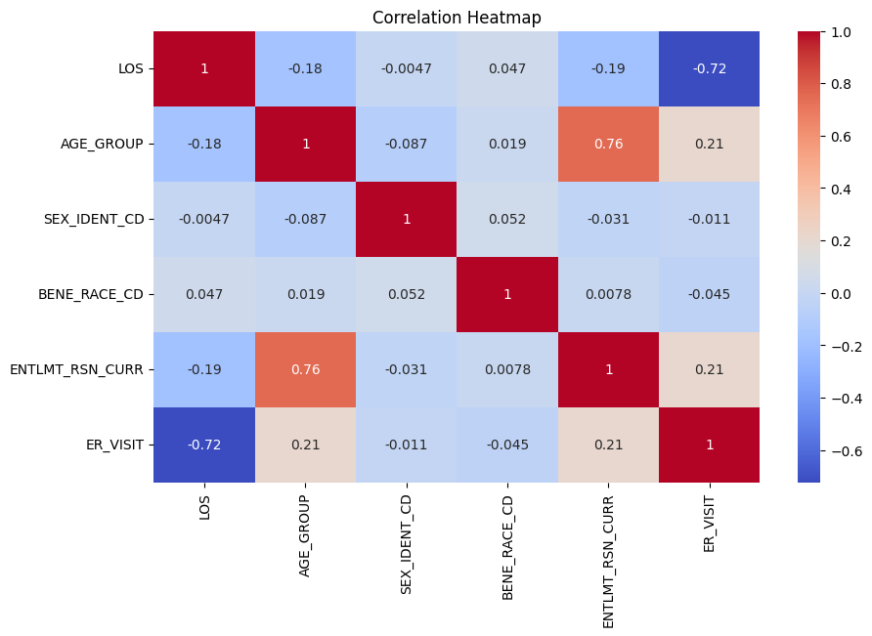
Figure 1:Correlation Heatmap of Patient Demographic Data vs ER Visit
The Heatmap shown in figure 1 positive correlation with AGE_GROUP, ENTLMT_RSN_CURR with ER_VISIT. Also, see positive correlation between AGE_GROUP and ENTLMT_RSN_CURR.

Heatmap: Correlation Heatmap of Patient Chronic Condition (ICD) Codes vs ER Visit
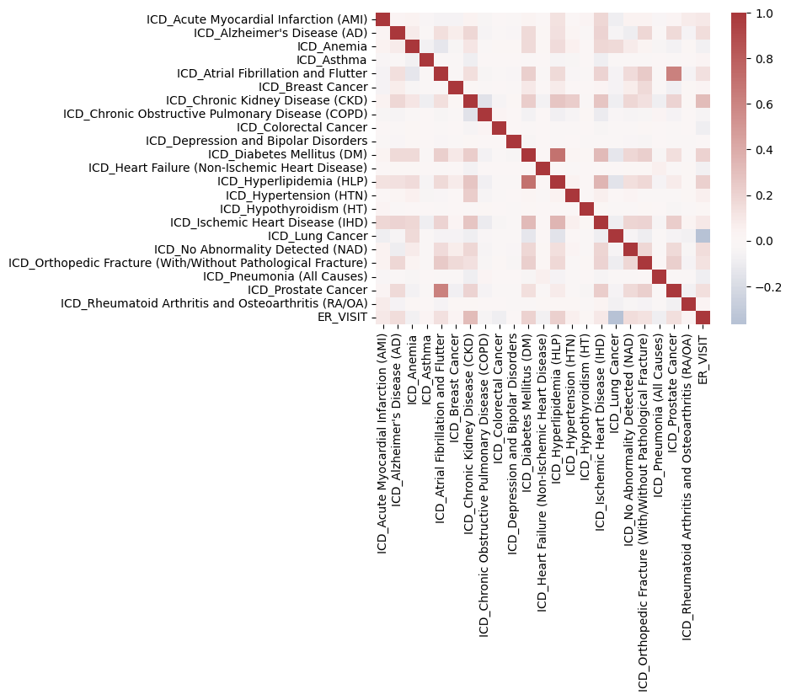
Figure 2: Correlation Heatmap of Claims ICD Code vs ER Visit
In Figure 2 we see ICD Chronic Kidney Disease (CKD) is positively correlated with ER_VSIIT.

Bar Chart:
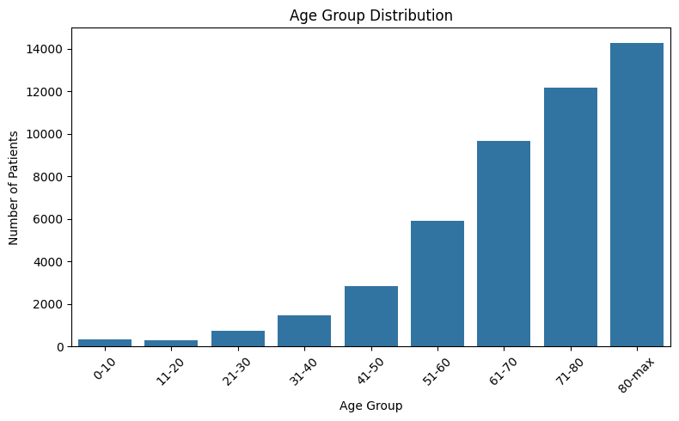
Figure 3: Patient Age Group Distribution

Chronic Condition Prevalence:
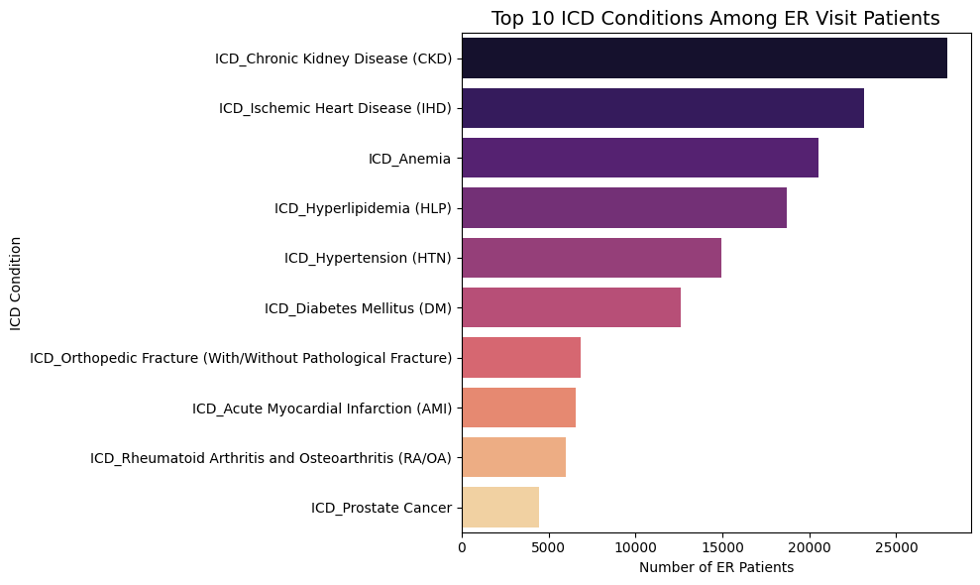
Figure 4: Chronic ICD Conditions in ER Patients

10 Chronic ICDs codes Positively Correlated with ER Visit
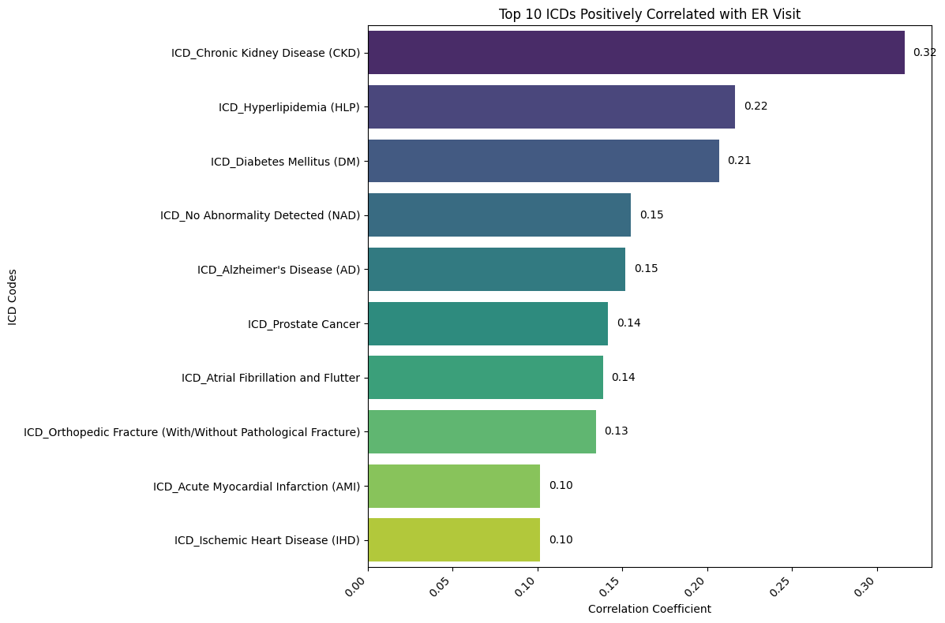
Figure 6: Chronic Conditions Positively Correlated with ER Visit

ER Visit Patterns for days of the week
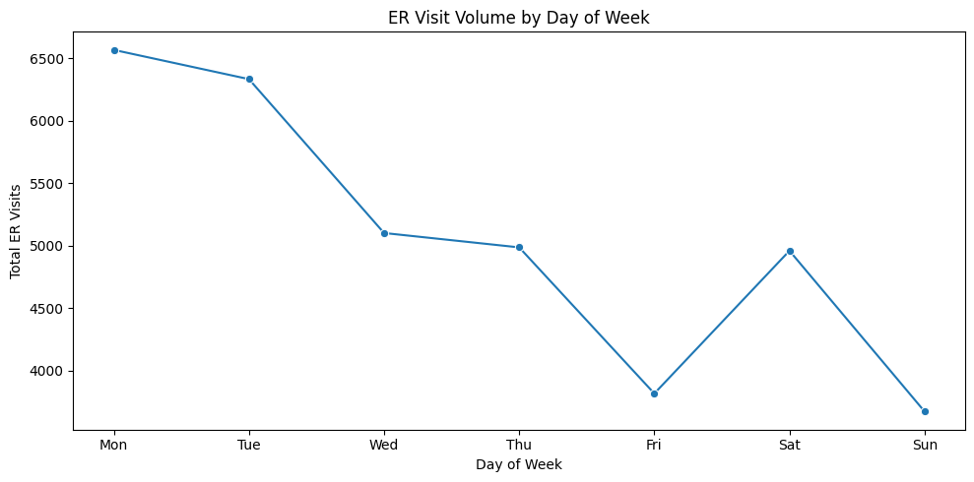
Figure 7: Patients Weekly Patterns for ER Visit

Statistical Methods:
This study employed both descriptive and inferential statistical techniques to analyze the relationship between patient characteristics and Emergency Room (ER) utilization.
1. Descriptive Statistics & EDA: Summaries and visualizations (bar plots, heatmaps) were created to explore the distribution of age, sex, entitlement codes, and ICD conditions.
2. Predictive Modeling: Logistic Regression, Random Forest, and XGBoost models were developed and evaluated using Accuracy, Precision, Recall, F1-Score, and ROC-AUC.
3. Feature Importance: For tree-based models, top features like CKD, IHD, and lung cancer were identified as the most influential predictors.
Machine Learning Modeling:
- A supervised classification model (e.g., Logistic Regression, Random Forest and XGBoost) was trained to predict ER visits.
- The dataset was split into training and testing sets
- Model evaluation metrics included:
  - Accuracy
  - Precision
  - Recall
  - F1-score
  - ROC-AUC
- A confusion matrix was used to visualize the model's performance on classifying ER vs. non-ER cases.

Modeling and Evaluation
This section outlines the approach and results of multiple machine learning models developed to predict Emergency Room (ER) visits using Medicare inpatient claims and demographic data. The models include Logistic Regression, Random Forest, and XGBoost classifiers, each trained using ICD-codes for chronic conditions and demographic features.
The primary features used for model training were:
- Input Features: All 22 chronic conditions from the Chronic ICD Columns
- Target Variable: ER_VISIT — a binary outcome (1 = ER visit, 0 = No ER visit)
Chronic ICD Columns:
'ICD_Acute Myocardial Infarction (AMI)'
"ICD_Alzheimer's Disease (AD)"
'ICD_Anemia'
'ICD_Asthma'
'ICD_Atrial Fibrillation and Flutter'
'ICD_Breast Cancer'
'ICD_Chronic Kidney Disease (CKD)'
'ICD_Chronic Obstructive Pulmonary Disease (COPD)'
'ICD_Colorectal Cancer'
'ICD_Depression and Bipolar Disorders'
'ICD_Diabetes Mellitus (DM)'
'ICD_Heart Failure (Non-Ischemic Heart Disease)'
'ICD_Hyperlipidemia (HLP)'
'ICD_Hypertension (HTN)'
'ICD_Hypothyroidism (HT)'
'ICD_Ischemic Heart Disease (IHD)'
'ICD_Lung Cancer'
'ICD_No Abnormality Detected (NAD)'
'ICD_Orthopedic Fracture (With/Without Pathological Fracture)'
'ICD_Pneumonia (All Causes)'
'ICD_Prostate Cancer'
'ICD_Rheumatoid Arthritis and Osteoarthritis (RA/OA)'

Model 1: Logistic Regression
Result:
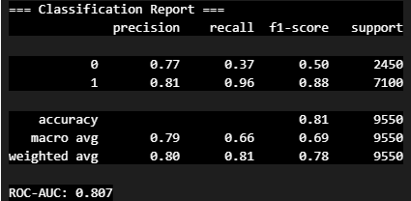
Accuracy: 81%
The model correctly predicted 81% of ER visit outcomes, indicating solid overall performance.
Precision (Class 1 - ER Visit): 0.81
81% of the predicted ER visits were indeed actual ER visits — this means the model keeps false positives relatively low.
Recall (Class 1 - ER Visit): 0.96
The model successfully identified 96% of all actual ER visits, demonstrating high sensitivity and very few missed cases.
F1-Score (Class 1 - ER Visit): 0.88
A strong balance between precision and recall, showing robust performance in identifying ER visits.
ROC-AUC: 0.807
This reflects strong discriminative ability, meaning the model does a good job distinguishing between ER and non-ER visits.
This model demonstrated high recall, meaning it effectively identified ER visits with low false negatives.

Feature Importance from Logistic Model:
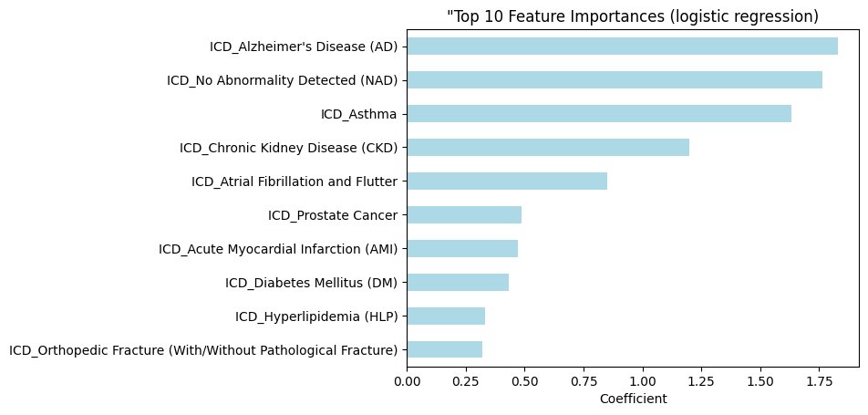
Figure 8: Top 10 Feature Importance from Logistic Regression

Model 2: XGBoost model for independent variables, Chronic Condition (ICD) codes and Target variable ER_VISIT
Result:
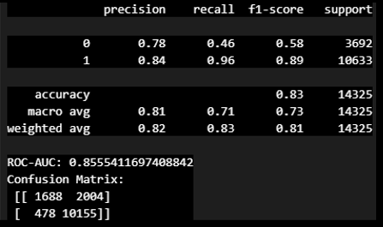
Performance:
- Accuracy: 83%
- Precision: 0.84
- Recall: 0.96
- F1-Score: 0.89
- ROC-AUC: 0.856
XGBoost slightly outperformed Logistic Regression, particularly in recall and AUC, suggesting superior sensitivity and class separation. It also handled nonlinear relationships and feature interactions more effectively.

The model misclassified 2004 non-ER cases as ER visits, but correctly identified over 10,000 ER cases, minimizing false negatives. The model missed 2004 non-ER cases, wrongly predicting them as ER visits. But it correctly identified 10,155 actual ER visits, with only 478 false negatives.

Feature Importance:
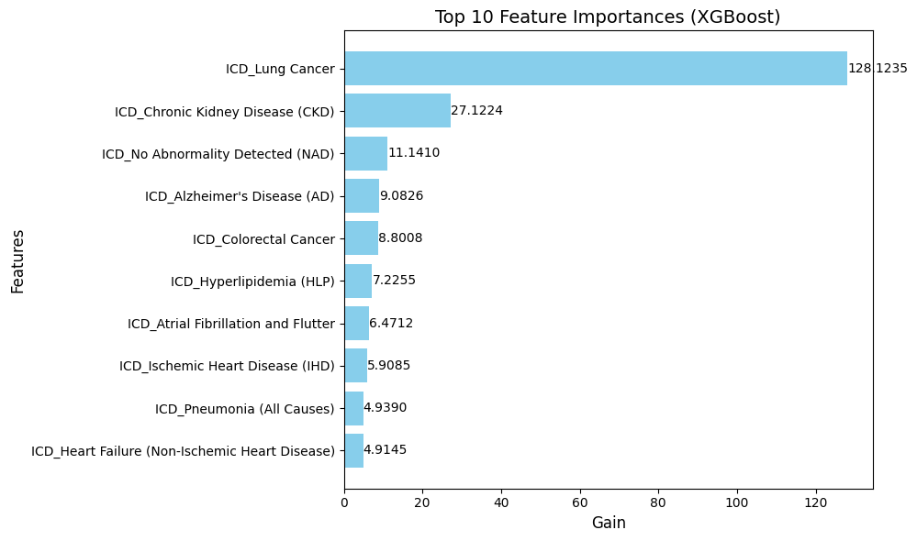
Figure 9: Top 10 Feature Importances from XGBoost

Model 3: Random Forest with ICD codes and ER visit as target variable
Input Features: ICD-coded chronic conditions
Result:
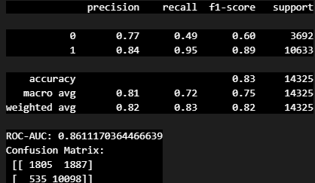
Random Forest achieved the highest accuracy and strong recall, highlighting its ability to capture key interactions in structured claims data. The top predictive features identified included:
- Chronic Kidney Disease (CKD)
- Lung Cancer
- Ischemic Heart Disease (IHD)

Model Comparison Result:
Metric | Logistic Regression | Random Forest | XGBoost
Accuracy | 0.81 | 0.83 | 0.83
Precision (class 1) | 0.81 | 0.84 | 0.84
Recall (class 1) | 0.96 | 0.95 | 0.96
F1-Score (class 1) | 0.88 | 0.89 | 0.89
ROC-AUC | 0.807 | 0.8611 | 0.8611

Conclusion:
XGBoost and Random Forest performed similarly, with both achieving high recall and AUC scores. XGBoost is slightly favored due to its robustness and efficiency.

Extended Modeling: Chronic ICD Codes + Demographic Combinations
To evaluate whether adding demographics improved model performance, Logistic Regression and XGBoost models were trained using combinations of ICD codes with:
- Age group
- Sex
- Entitlement reason
Model Inputs:
- ICD + AGE_GROUP
- ICD + SEX
- ICD + ENTLMT_RSN

ROC Curve Comparison:
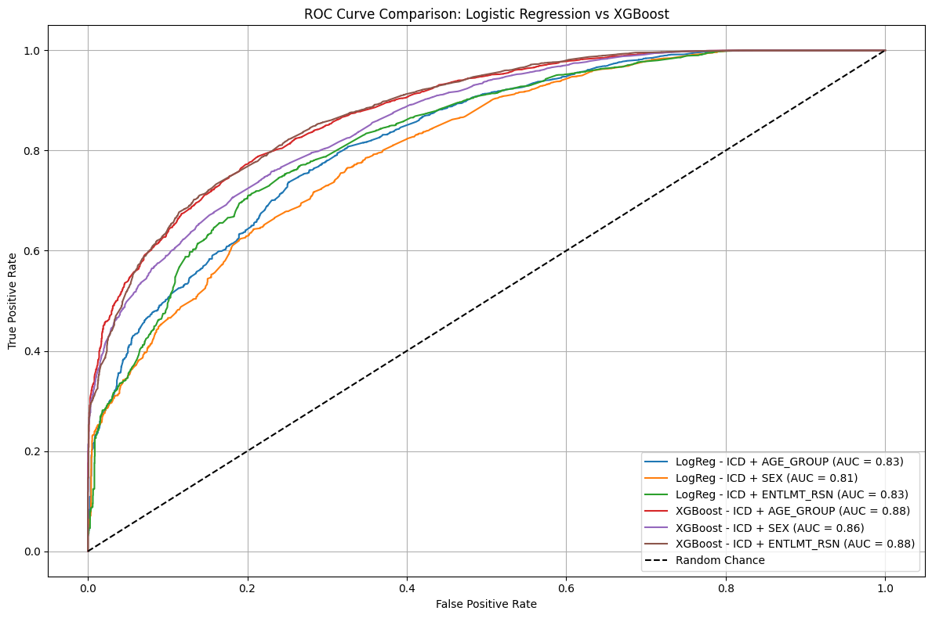
Figure 10: ROC Curve Comparison for Logistic vs. XGBoost

Model Comparison: Logistic and XGBoost
Metric | ICD + AGE_GROUP | ICD + SEX | ICD + ENTLMT_RSN
Accuracy (LogReg) | 0.806981 | 0.806283 | 0.811518
Precision (LogReg) | 0.824115 | 0.811846 | 0.822779
Recall (LogReg) | 0.940983 | 0.962222 | 0.951132
ROC_AUC (LogReg) | 0.82619 | 0.80693 | 0.831886
Accuracy (XGBoost | 0.832531 | 0.826108 | 0.834485
Precision (XGBoost | 0.842788 | 0.836332 | 0.856896
Recall (XGBoost | 0.952166 | 0.95226 | 0.932995
ROC_AUC (XGBoost | 0.880021 | 0.860689 | 0.880377
So, XGBoost model with ICD + ENTLMT_RSN is the best-performing model based on a balanced combination of Precision, ROC-AUC, and Accuracy.

Reasons why XGBoost Performs Better:
Aspect | XGBoost | Logistic Regression
Model Type | Tree-based (nonlinear, ensemble) | Linear (assumes linear relationships)
Feature Interaction | Captures complex interactions | Limited unless manually added
Handling of Nonlinearities | Excellent (trees split on thresholds) | Poor (needs transformation)
Performance on Structured Data | Very strong | Can be good, but often weaker
Sensitivity to Outliers | Less sensitive (trees are robust) | Sensitive (can skew coefficients)

Key Takeaways from the Results:

Model Performance:
- XGBoost achieved the highest ROC-AUC score (0.88), followed by Random Forest (0.86) and Logistic Regression (0.81), indicating strong predictive performance.
- All models showed high recall for class 1 (ER visits), with XGBoost reaching 96%, demonstrating its ability to detect true ER cases effectively.

Top Predictive Features:
- Chronic Kidney Disease (CKD), Lung Cancer, and Ischemic Heart Disease (IHD) were the most influential ICD-coded chronic conditions associated with ER visits.
- Demographic features such as AGE_GROUP_51-60 and ENTLMT_RSN_CURR_DIB (disability entitlement) also showed strong predictive importance.

Feature Engineering Impact:
- One-hot encoding of chronic ICD conditions and demographic variables significantly enhanced model interpretability and performance.

Conclusion:
This study successfully demonstrated the ability to predict Emergency Room (ER) visits using Medicare claims data, with a focus on chronic health conditions and patient demographics. Among the various models evaluated, XGBoost consistently outperformed Logistic Regression and Random Forest, achieving the highest ROC-AUC score of 0.88, indicating strong discriminative power in identifying patients likely to use ER services based on inpatient claims and patient demographic data.
The analysis revealed that chronic conditions such as Chronic Kidney Disease (CKD), Lung Cancer, and Ischemic Heart Disease (IHD) were among the top predictors of ER visits. Additionally, demographic factors like age group and sex, along with insurance entitlement reasons (e.g., disability or ESRD), significantly influenced ER utilization patterns.
This insight can help healthcare providers and policymakers proactively identify high-risk individuals and implement targeted care coordination and management strategies, such as preventive outreach by Primary Care Physician (PCP) and enhanced care coordination. Doing so may not only improve patient outcomes but also reduce the financial burden associated with avoidable ER visits.
Future work can include using geographic patterns, readmission intervals, and temporal trends (e.g., seasonality) to further refine prediction models and support real-time risk stratification in healthcare systems.

Citations & References:
[1] Suh, Y., Jeong, J., Park, S.M. et al. Development of a claims-based risk-scoring model to predict emergency department visits in older patients receiving anti-neoplastic therapy. Sci Rep 14, 1485 (2024). https://doi.org/10.1038/s41598-024-51981-0

[2] Y. Sun, B.H. Heng, S.Y. Tay, E. Seow, Predicting hospital admissions at emergency department triage using routine administrative data, Acad. Emerg. Med. 18 (2011) 844–850.

[3] Clare Allison Parker MD, et al. “Predicting Hospital Admission at the Emergency Department Triage: A Novel Prediction Model.” The American Journal of Emergency Medicine, W.B. Saunders, 29 Oct. 2018.

[4] Fabrice Mowbray, et al. “Predicting Hospital Admission for Older Emergency Department Patients: Insights From Machine Learning.” International Journal of Medical Informatics, Elsevier, 16 May 2020, www.sciencedirect.com/science/article/abs/pii/S1386505619314510#preview-section-references.

[5] Hong, Woo Suk, et al. “Predicting Hospital Admission at Emergency Department Triage Using Machine Learning.” PLOS ONE, Public Library of Science, journals.plos.org/plosone/article/authors?id=10.1371%2Fjournal.pone.0201016. Accessed 20 Mar. 2025.

